Re-emergence of Cholera in the Americas: Risks, Susceptibility & Ecology

Mathieu Poirier

University of South Florida

The reemergence of cholera in Haiti has established a new reservoir for the seventh pandemic which threatens to spread to other countries in the Americas. Statistics from this new epidemic are compared to the 1991 Peru epidemic (Delgado, Morales, Mendez, & Cravioto, 2011), which demonstrated the speed and complexity with which this disease can spread from country to country. Environmental factors implicated in the spread of Vibrio cholerae such as ocean currents and temperatures as well as biotic factors from zooplankton to waterfowl are seen to pose a risk for many countries in the Americas. The movement of people and goods from Hispaniola are mostly destined for North America, but occur to some degree throughout the Americas. These modes of transmission, however, are completely dependent upon risk factors within these countries such as water quality and availability of sanitation. While North America is observed to have excellent coverage of these deterrents of disease, many countries throughout Central and South America lack these basic services.

Introduction

After an absence of more than 100 years, cholera has returned to the island of Hispaniola and the seventh pandemic now threatens to return to the rest of the Americas (Arie, 2010). Centuries of research on the causative agent of cholera has revealed Vibrio cholerae to be a constantly evolving bacterium with numerous reservoirs, routes of transmission, and variations in the manifestation of subsequent disease (Kaper, Morris, & Levine, 1995). In order to evaluate this new epidemic, it is imperative that the 1991 cholera epidemic which began in Peru and spread to most American countries be analyzed to give context to the epidemiology of the disease. Using the context of the 1991 cholera epidemic along with recent research it may be possible to predict the future spread of this epidemic.
The seventh cholera pandemic began in Sulawesi in 1961 and quickly spread through South Asia where it became endemic. This newest and longest-lasting pandemic caused by V. cholerae serotype O1 El Tor has been differentiated from other strains by a greater ability to survive in the aquatic environment, a lower rate of severe manifestation of disease, and lower immunological protection against re-infection (Clemens et al., 1991; Kaper et al., 1995; Rawlings, Ruiz, & Colwell, 2007).

The Haitian Epidemic in Context

The specific origin of the 1991 epidemic has been hypothesized to be a point source introduction, but was most likely a result of a rapid growth of environmental bacteria due to an El Niño event after it was introduced from an endemic area to the coast of Peru (Gil et al., 2004). This was further confirmed by the identification of seven patients in five different cities separated by over 1,000 kilometers presenting clinical symptoms of cholera several months before the official start of the epidemic (Seas et al., 2000). Subsequently, a large-scale epidemic beginning in Peru spread to Ecuador within two months and to Colombia, Brazil, and Chile within five months (Mata, 1994).
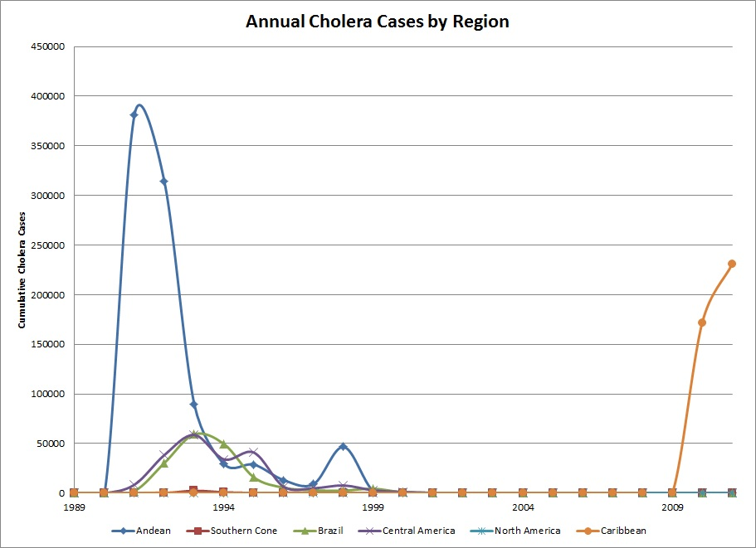
The fact that Mexico was the next country to report an outbreak provides an important example of the complex patterns of transmission that cholera can exhibit. Before any Central American country was hit by the disease, a case was detected in the rural city of San Miguel Totolmaloya and the disease quickly spread to impoverished, rural areas in the southern states of Mexico (Borroto & Martinez-Piedra, 2000). Two hypotheses have been proposed to explain why an index case appeared in such a remote, distant area from the origin of the outbreak. One suggests that the disease was imported from South America by drug traffickers using illegal airstrips in the area (Sepúlveda, Valdespino, & García-García, 2006). The other is that the Mexican outbreak was an independent event arising from environmental V. cholerae off the coast of Mexico. This is supported by serological evidence indicating that El Tor V. cholerae, classical V. cholerae, and hybrid strains were all present from 1991-1997 in Mexico. Since the classical and hybrid biotypes were never found in South America, the best explanation for the presence of these unique biovars is that they came from the Gulf of Mexico (Alam et al., 2010). The Mexican experience demonstrates the importance of both human and environmental factors in the spread of cholera.
Figure 1. Annual cholera cases by region (Pan American Health Organization, 2011b; World Health Organization, 2011)
From Mexico, the disease spread through Central America eventually bringing the total countries reporting cholera to 21 with a total of more than 775,000 cases by the end of 1992 (World Health Organization, 2011). The number of cases - which can be observed by region in Figure 1 - gradually diminished through 1997, but rapidly increased in 1998 after an increase in ocean temperature off of the Pacific coast of South America due to an El Niño event (Gil et al., 2004). Eventually, cases dwindled during the early 2000s when there were mostly small-scale outbreaks until cholera was eliminated from the South and Central America in 2005, except for five cases in Paraguay in 2009. It is striking that the Caribbean region was spared during these epidemics. One of the possible reasons, other than the geographical separation, could be the extremely limited trade relations between the Caribbean region and the Central and South American countries that limited the exchange of people and materials (United Nations Conference on Trade and Development, 2011).
The Americas enjoyed only a short reprieve from cholera until October 21st 2010, when the first case of cholera was officially confirmed by the Centers for Disease Control and Prevention (CDC) and the Ministère de la Santé Publique et de la Population (MSPP) of Haiti (Pan American Health Organization, 2010). Despite initial suspicion that aquatic environmental V. cholerae was to blame for the epidemic, further investigation uncovered the likely source to be Nepalese soldiers serving as part of the United Nations Stabilization Mission in Haiti. This investigation found that the first cases actually appeared on October 14 in Méyè and infected the Artibonite River, which fueled the spread of the bacteria through the rest of the country. The conclusion is supported by DNA fingerprinting and genotyping suggesting a geographically distant source of the bacterium and the elevated number of cases observed along the Artibonite River (R. Piarroux et al., 2011).
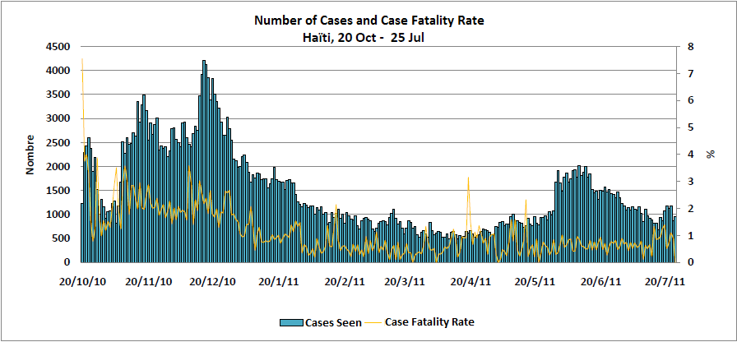
As shown in figure 2, after an initial peak in the number of cases occurring around the Artibonite River, there was a lull in cases in early November 2010. The subsequent peak of cases could possibly be due to the increased social gathering, contact and feasting associated with the observance of the ‘Day of the Dead’ on November the 2nd, one of the most important festivals of Haiti (Metraux, 1972; ProQuest, 2005). The peak attained a maxima in December 2010 and gradually decreased until another smaller rise in cases was seen beginning in May 2011 at the onset of the rainy season. The weather changes raise the possibility of an increase in the number of cases in the Dominican Republic, which hitherto has recorded less than 4% of the total cholera cases on Hispaniola (Ministère de la Santé Publique et de la Population, 2011a; Pan American Health Organization, 2011a). In conjunction with these numbers, Andrews & Basu predict approximately 779,000 new cases and 11,100 deaths between March and November 2011 with the greatest numbers for the Port-au-Prince, Artibonite, and Nord Departments (Andrews & Basu, 2011).
Figure 2 - Suspected cholera cases and case fatality rate in Haiti (Modified by authors from Ministère de la Santé Publique et de la Population, 2011b)
The case fatality rate (CFR) has decreased since the beginning of the outbreak (figure 2). From over 3% the month after the beginning of the epidemic, the CFR has decreased to 1.4% as of late July 2011. The CFR spike in April and May 2011 came at a time of reduced funding for NGOs in Haiti partially due to an underestimation of the severity of the epidemic by the WHO and other multilateral organizations (Johnston & Bhatt, 2011). One explanation for this significant deterioration in the quality of care may be the scaling down of operations around the country by these NGOs in response to financial difficulties. In fact, the number of operational cholera treatment centers in Haiti was cut in half from 96 in February 2011 to 48 in May 2011 (Center for Economic and Policy Research, 2011). This draw down of cholera prevention efforts occurred in the face of widespread knowledge that the upcoming rainy season would increase cases around the country (Johnston & Bhatt, 2011). The national averages, however, mask the disparity between the lowest CFR of 0.6% in Port-au-Prince and the highest CFR of 5.3% in the Departement Sud Est (Ministère de la Santé Publique et de la Population, 2011b). This disparity in mortality can be explained by health care delivery challenges comprising of difficulties in geographical and financial accessibility to health care, poor infrastructure, inadequate transport services, and inadequate health personnel, as well as the extent of community involvement (Farmer et al., 2011). This difficulty of supplying remote areas was overcome in Ecuador during the 1991 epidemic by strategies such as sending out oral rehydration packets coupled with soft drinks (Malavade et al., 2011). Similar innovative practices may be considered for implementation in Hispaniola to reduce mortality.
This new epidemic of cholera engenders a human reservoir for toxigenic V. cholerae in the Americas and raises the spectre of further spread of the disease to other countries. To evaluate this possibility; both human dependent and ecologically mediated transmission of the bacterium must be compared with each country’s potential for disease spread.

Environmental Reservoirs

The ability of V. cholerae to survive in aquatic environments is now well established. The bacterium attaches to chitin – the most abundant biopolymer in the marine, brackish water, and estuarine environments. This gives it an almost limitless habitat and contributes to its pathogenicity (Pruzzo, Vezzulli, & Colwell, 2008). Aside from that, it allows V. cholerae to bind to the chitinous gut and carapace of zooplankton. There are numerous other reservoirs that include non-biting midges, phytoplankton, aquatic plants and protozoa. These reservoirs are responsible for the infection of higher organisms such as marine bivalves, fish, crustaceans, and possibly even marine mammals. This has led to workers suggesting a decrease in copepods to have a measurable effect in the control of cholera. Illustratively, in an area of endemic cholera in rural Bangladesh, simple filtration of drinking water through sari cloth in order to remove copepods has been found to reduce cholera incidence by 48% (Colwell et al., 2003) Additionally, waterfowl can ingest and spread V. cholerae attached to its feathers and feet (Halpern, Senderovich, & Izhaki, 2008; Vezzulli, Pruzzo, A. Huq, & Colwell, 2010). These environmental reservoirs have been found to have a significant impact on human disease and are affected by climatic factors. Although the bacterium is able to survive in salinities ranging from 0% to 45% and temperatures above 5°C, it has been found to thrive in certain conditions. These abiotic factors include high temperature near 35°C, salinity below 5% for optimal toxin expression, pH around 8.5, more sunlight, and increased rainfall. Changes in these factors lead to varying degrees of cholera seasonality which are low in equatorial areas such as the Caribbean and Central America and higher in subtropical areas such as the Southern Cone and North America (Emch, Feldacker, M. S. Islam, & M. Ali, 2008; A. Huq et al., 2005; Lipp, A. Huq, & Colwell, 2002; Ruiz-Moreno, Pascual, Emch, & Yunus, 2010). This means that while there may be periods of low environmental cholera transmission in the higher latitudes, environmental transmission rates are relatively even year-round near the equator.
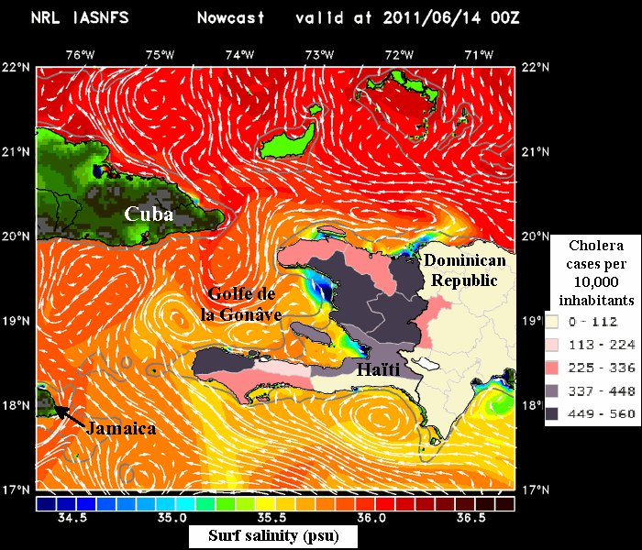
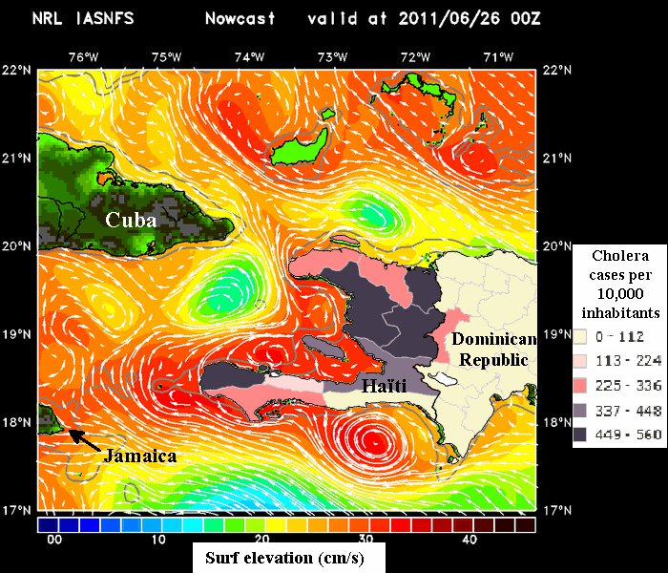
The marine environment can have a significant impact on the spread of cholera from the island of Hispaniola. There is evidence of non-toxigenic V. cholerae thriving in the Caribbean Sea after intense rains create low salinity conditions (Fernández-Delgado et al., 2009). Currently, the most affected areas are located along the largest river on Hispaniola – the Artibonite River. This river mostly flows at low altitude and high temperature, and directly into the largest mangrove forest in Haiti – all of which are conditions that are ideal for the growth of environmental V. cholerae (Borroto & Martinez-Piedra, 2000). This area of low salinity can be clearly seen in figure 3 in the north of the Golfe de la Gonâve marked by dark blue coloration.
Figure 3. Surf salinity and cholera incidence rate (Naval Research Laboratory, 2011; Pan American Health Organization, 2011c)
Figure 4 - Surf elevation and cholera incidence rate (Naval Research Laboratory, 2011; Pan American Health Organization, 2011c)
Though mangrove coverage is sparse in Haiti, there is greater coverage in the north of the neighboring Dominican Republic, and nearby Cuba has the second largest mangrove forests in North and Central America. The proximity of these mangroves to the epicenter of a cholera epidemic is cause for concern, because they offer low salinity and ideal conditions for V. cholerae hosts to thrive. Establishment of V. cholerae in these habitats could make cholera endemic here as it has been for decades in South Asia. Countries further away from Hispaniola have similar environments, but may be protected to some degree. Although there is significant mangrove coverage around the Gulf of Mexico, there is reason to believe that the Loop Current would prevent many organisms carrying the bacteria from reaching the Gulf Coast because of low nutrient availability and physical pressures due to fluid dynamics (Rathmell, 2007). The same cannot be said for Cuba, which appears to be the destination of surface currents originating from Haiti as seen in Figure 4.
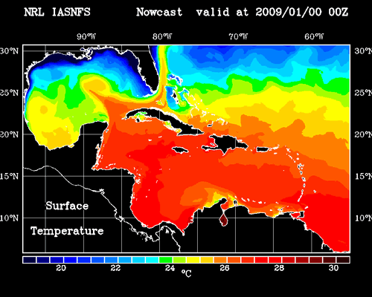
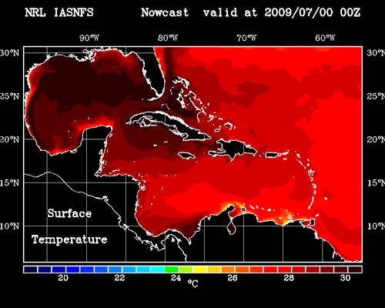
Water temperature has been observed to be the single strongest predictor of cholera outbreaks, though some of this observed effect may be due to increased river flow occurring concurrently (A. Huq et al., 2005; Jutla, Akanda, Griffiths, Colwell, & S. Islam, 2011). The water temperature around Hispaniola remains very stable year-round, so it is unlikely to be a significant contributor to environmental propagation of V. cholerae on this island. This is in contrast to other locations around the Caribbean, which can be seen to have greater seasonal variation in water temperature in Figure 5. Specifically, the Gulf coast of the United States and Mexico appear to have the greatest variation in sea surface temperature, which could mean larger peaks and troughs of environmentally transmitted cases were an epidemic to spread to the region.
Figure 5 - Average sea surface temperature in July (left) and January (right) (Naval Research Laboratory, 2011)
One environmental factor which is not dependent upon oceanographic dynamics for the movement of V. cholerae is the migration of waterfowl. Many American species of birds have been proven to carry the bacteria long distances and most of these species have been observed to spend time in the Caribbean (Buck, 1990; Ogg, Ryder, & H. L. Smith, 1989). For example, the Blue Winged Teal is the most common winter resident duck in the Caribbean and has a range that includes Central America and northern South America. Other birds such as pelicans, coots, cormorants, heron and killdeer migrate over a massive range from northern Canada to the Southern Cone. There is greater abundance of migratory birds in the surrounding Caribbean islands, southern United States, Central America, and northern South America with less species wandering far from the equator (DeGraaf & Rappole, 1995).
In summary, it appears that the islands of Hispaniola, Cuba, Jamaica, and Puerto Rico are at risk of environmental V. cholerae being transported to their coasts by river flow and currents into their large mangrove forests with minimal effect from sea temperature. Conversely, continental North and South America seem to be protected by both the Loop Current and cooler sea surface temperatures for much of the year. Waterfowl, however, may carry the bacteria to almost any area in the Americas.

Human Mediated Transmission

In the past, Haitians have been discriminated against due to actual or perceived disease status by both governments and the general population of other countries (Harper & Raman, 2008). This attitude still persists in spite of biological and epidemiological irrelevance. Persons who travel out of Hispaniola are just as likely to be foreigners returning to their original destination. Also, ships that can transfer infected ballast water almost all sail under foreign flags (Central Intelligence Agency, 2011).
International shipping has historically been the main driving force behind the spread of epidemic cholera around the world (Hamlin, 2009). Today, the shipping of goods remains an important factor to examine. The United States Food and Drug Administration emphasized this danger during the 1991 epidemic by advising that all ships travelling from affected countries exchange ballast water on the high seas before entering American ports (McCarthy & Khambaty, 1994).
Although statistics on specific destinations of shipping leaving Haitian ports is unavailable, the breakdown of Haiti’s trade partners in figure 6 approximates the destinations of these ships. The overwhelming majority of trade heads to the United States, followed by the neighboring Dominican Republic, and Canada. After these trading partners, Mexico, Colombia, Brazil, El Salvador, and Brazil are the next largest buyers of Haitian goods (United Nations Conference on Trade and Development, 2011). In total, there are 26 registered trade partners ranging from Nicaragua with only $2,385 of goods to the United States with over $419 million of exported goods. This disparity must be tempered with the fact that only one instance of infected ballast water is needed to infect an aquatic habitat. Also, the dollar value of goods being exported may not directly correlate with the amount of goods being shipped, and thereby the shipping traffic, if prices vary according to trade partner.
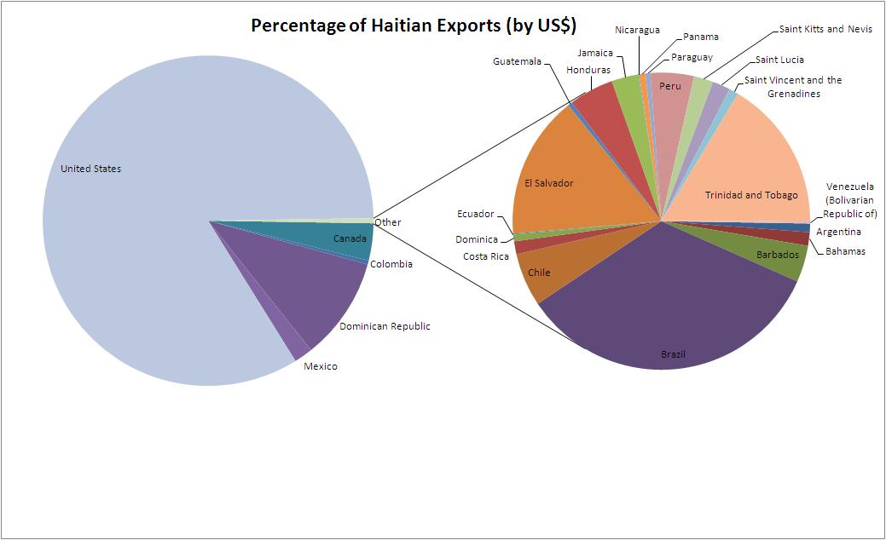
A specific category of goods which must be placed under increased scrutiny is that of fish, crustaceans, and mollusks, which have been proven to be the cause of cholera outbreaks in the past (Kaper et al., 1995). Unfortunately, only four countries report importing fish, crustaceans, or mollusks from Haiti. These are Canada at almost $2.9 million worth, the United States at $1.7 million, Honduras at $38 thousand, and Mexico at $11 thousand (UNCTAD, 2011). The few countries reporting this statistic limits our ability to know the true status of the exportation of these goods.
Figure 6 - Percentage of Haitian exports by US$ (United Nations Conference on Trade and Development, 2011)
As the origin of the Haitian cholera epidemic has proven, the movement of infected persons by aircraft can be a source of an epidemic. Despite this, quarantine or the use of cordon sanitaire is not useful in preventing the spread of this disease and is not recommended by the WHO and PAHO (PAHO, 2011). One reason for this is the fact that severe diarrhea only occurs in a small number of infected patients. It is estimated that 90% of cholera episodes are of mild or moderate severity and that there may be anywhere from 3 to 100 asymptomatic carriers of the bacteria for every symptomatic carrier (King, Ionides, Pascual, & Bouma, 2008; Zuckerman, Rombo, & Fisch, 2007). In addition, past efforts to halt the spread of cholera using quarantine have failed to do so and divert valuable resources away from treatment and prevention measures (Glass, Claeson, Blake, Waldman, & Pierce, 1991; Sepúlveda et al., 2006; Wong, Ang, James, & Goh, 2010).
The major destinations of aircraft departing from Haiti correlate closely with the trade partners in large part due to the presence of expatriate communities. As of November 2010, the United States accounted for 76% of passenger flights followed by the Dominican Republic and other Caribbean islands at 17%, France with 4%, Canada with 2%, and Panama with 2% (Centers for Disease Control and Prevention, 2010). These officially recorded statistics on the movement of persons do not include passengers using cruise liners and naval vessels to travel, which also could introduce the disease to a new area. Overall, most of the movement of people is to developed countries with less travel to the Caribbean and Central America.

Susceptibility to Disease

Cholera has spread in the western hemisphere through environmental reservoirs, the shipping of goods, and through movement of persons. However, these routes of transmission become irrelevant if the population has advanced water and sanitation measures that prevent the disease from ever taking hold. For example, despite having several cases of endemic toxigenic serogroup O75 cholera and having imported at least 23 cases of serogroup El Tor O1 Ogawa cholera from Haiti, there have only been two recorded cases of secondary transmission within the borders of the United States since 1965 (Centers for Disease Control and Prevention, 2010; Newton et al., 2011; Tobin-D’Angelo et al., 2008). By evaluating the risk factors for disease, the true risk of epidemic cholera spread is evident.
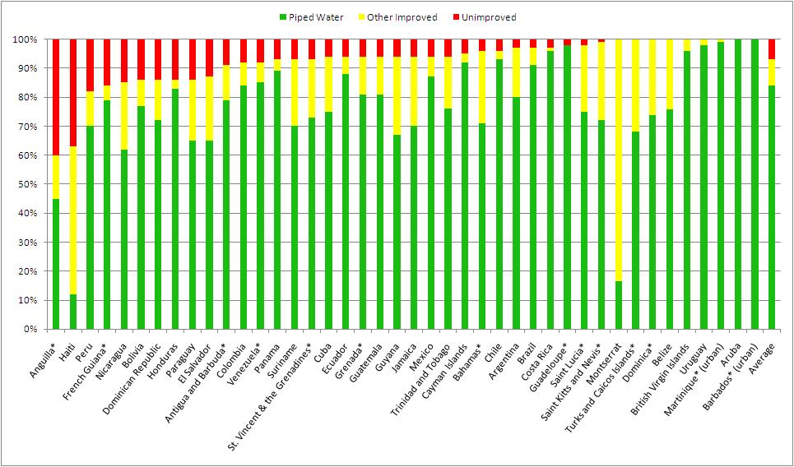
One major risk factor in the spread of cholera is the lack of a clean water source as demonstrated by John Snow (Snow, 1936). In addition, there is ample evidence of the importance of water quality from the 1991 epidemic. Contaminated water sources and the resultant water quality were found to be the most common cause for disease in separate studies in Peru, Mexico and Ecuador (Borroto & Martinez-Piedra, 2000; Malavade et al., 2011; Swerdlow et al., 1992). Figure 7 presents a breakdown of the percentage of every country’s population served by piped water, improved source, or unimproved water source except for the United States and Canada which both report 100% piped water coverage. These categories do not present a perfect hierarchy, since decayed or clandestine water connections have been shown to be worse than high quality improved water sources (Bhunia, Ramakrishnan, Hutin, & Gupte, 2009; Malavade et al., 2011). Also, these averages obscure the significant disparities between high and low socio-economic status groups within countries as well as between urban and rural communities (WHO/UNICEF Joint Monitoring Programme for Water Supply and Sanitation, 2010).
Figure 7 – 2008 water source statistics (asterisk denotes 2003 statistics) (WHO/UNICEF Joint Monitoring Programme for Water Supply and Sanitation, 2010)
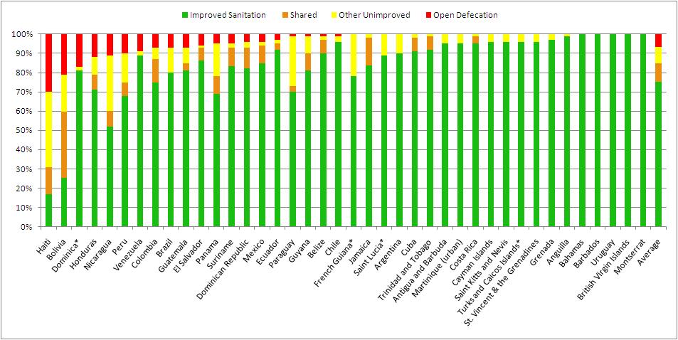
It is no surprise that there has been an explosion of cases in Haiti since it has the worst percentage of piped water coverage and water quality in the Americas. . Countries at risk of marine spread such as Cuba, Jamaica, the Lesser Antilles nations, and Central America all have a significant percentage of their population drinking from an unimproved water source. Some of Haiti’s top trading partners of Mexico, Colombia, Brazil, Trinidad and Tobago, and El Salvador similarly exhibit potential for the spread of cholera due to poor water quality. Finally, the top destinations of flights are mostly covered by excellent water quality except for Panama and several Caribbean nations.
Figure 8 – 2008 sanitation statistics (asterisk denotes 2003 statistics) (WHO/UNICEF Joint Monitoring Programme for Water Supply and Sanitation, 2010)
Another crucial factor needed to break the cycle of fecal-oral transmission of cholera is the percentage of population covered by improved sanitation. Improving sanitation has been a cornerstone of cholera prevention and also has been shown to dramatically lessen the impact of epidemics (Bertuzzo et al., 2011; Ryan, 2011). As with water quality, these statistics need to be compared to other factors. For example, even though the residents of Santiago, Chile had very good sanitation coverage in 1991, the resulting sewage was used untreated in vegetable cultivation for human consumption. This resulted in an epidemic which was curbed greatly once this practice was discontinued (Levine, 1991).
Sanitation coverage statistics for the countries of the Americas are summarized in figure 8. Tellingly, Haiti has the worst sanitation coverage of any country in the Americas, while the Dominican Republic has slightly better sanitation coverage compared to its water quality statistics. With the exception of Dominica and Central America, the countries at risk of marine spread have fairly good coverage of improved sanitation. The major trading partners of Mexico, Colombia, Brazil, and El Salvador, however, have significant segments of their population practicing open defecation. The major flight destinations again have excellent sanitation coverage except for Panama and some Caribbean nations.
With most diseases, a protective factor in preventing the spread of disease is natural or artificially acquired immunity. The protective effects of naturally acquired immunity to El Tor O1 cholera after infection has been demonstrated to be less than that of the classical biotype, and the initial protective effect has been estimated to be anything from 90% protective to negligible protection (Clemens et al., 1991; Kaper et al., 1995). Unfortunately, this effect seems to be short lived. The most important factor in the immune response appears to be the presence of vibriocidal antibodies, which reach effective levels between one to three weeks after infection. Although some claim the resulting protective immunity lasts for 3 to 9 years, most estimate it to be as short as a couple months for mild infection and one to two years for severe infections (Glass et al., 1985; King et al., 2008; Sanches, Ferreira, & Kraenkel, 2011).
This means that for a population to have immunological protection against cholera, they must be repeatedly exposed to the bacterium at least once every couple years. This has been observed to happen in Bangladesh, where the population with detectable levels of vibriocidal antibodies reached 50% by age ten and 80% by age 15 (Glass et al., 1985; Woodward, 1971). The Americas, however, have not had recorded cases of cholera in any significant number within the time span of plausible immunological protection. The only possible scenario for the presence of protective immunity is that there are remote endemic areas in the Americas which do not report cases of cholera because of the mildness of symptoms and the fact that endemic cholera overwhelmingly attacks children under the age of five (Deen et al., 2008). Despite this possibility, it is safe to assume that the population of the Americas is immunologically naïve to V. cholerae because any immunity gained from the previous 1991 epidemic has been lost over time.
An active surveillance system for diarrheal diseases and easy accessibility of primary health care is critical to the early awareness of the public health system to the existence of suspicious cases of cholera in the community and thereby early implementation of remedial measures. Finally, public health education on cholera prevention practices such as hand washing, safe food handling, safe water storage, and safe disposal of cadavers also have significant impacts on preventing the transmission of cholera (Malavade et al., 2011; Mata, 1994; Swerdlow et al., 1992). It is important to note, however, that education alone cannot succeed in preventing cholera without supplies and facilities to put knowledge into practice (Farmer et al., 2011).

Conclusion

After a brief reprieve from the menace of cholera, the seventh pandemic has returned to the Americas on the island of Hispaniola. Public health officials have the benefit of a broad body of work from the 1991 epidemic to predict the future path of this new wave. There are lessons to be learned from the weather related factors which influenced the beginning of the epidemic, the variety of factors which contributed to the spread, and the factors which put these countries at risk in the first place. There is a risk of cholera becoming endemic around the island of Hispaniola – especially in estuarine areas such as the mouth of the Artibonite. From these locations, there is a chance that organisms may be transported to other locations in the Caribbean. Haiti’s major trade partners and flight destinations have also been analyzed and compared to their risk factors for epidemic cholera introduction. Almost every country outside of North America and the Southern Cone exhibits the risks of lack of safe water and sanitation in conjunction with the opportunity for the pandemic to spread to their borders.
Finally, there appears to be an illusory dichotomy developing between debility before an increasingly intimidating bacterium, and the inaction of implementing basic health services as the knowledge of the disease continues to grow. There is cause for concern because not only has the seventh pandemic not been halted, it has expanded into Africa and reemerged in the Americas. The O139 Bengal cholera serotype, which some describe as the eighth pandemic, has spread rapidly in south Asia by infecting even those who are immune to the O1 serotype (Faruque et al., 2003). A new strain of the El Tor O1 V. cholerae has been found to express the more dangerous classical cholera toxin, increasing the proportion of severely dehydrated cholera patients in the affected area from approximately 35% to over 70% (Siddique et al., 2010). Even more disconcerting may be the revelation that V. cholerae is so widespread through the earth’s oceans that it will never be eradicated (Ryan, 2011).
Despite these alarming trends, cholera remains a disease which is completely controllable by simple interventions which have been known since the days of Koch. With universal access to safe water and sanitation, along with a robust public health preparedness system, there would only be sporadic cases acquired from environmental sources. Over fifty years ago it was clear that cholera epidemics “do not create abnormal situations, rather they emphasize normal aspects of abnormal situations. An epidemic intensifies certain behavior patterns, but those patterns, instead of being aberrations, betray deeply rooted and continuing social imbalances” (McGrew, 1960, pg. 71). The 2010 cholera epidemic has only brought to light the fact that the right to clean water, sanitation, and public health protection has been denied to millions of people throughout the Americas. Until these social imbalances are corrected, cholera will continue to spread, and the people of the Americas will continue to pay the price.

References
Alam, M., Nusrin, S., Islam, A., Bhuiyan, Nurul a, Rahim, N., Delgado, G., Morales, R., et al. (2010). Cholera between 1991 and 1997 in Mexico was associated with infection by classical, El Tor, and El Tor variants of Vibrio cholerae. Journal of clinical microbiology, 48(10), 3666-3674. doi:10.1128/JCM.00866-10
Andrews, J. R., & Basu, S. (2011). Transmission dynamics and control of cholera in Haiti: an epidemic model. Lancet, 377(9773), 1248-1255. Elsevier Ltd. doi:10.1016/S0140-6736(11)60273-0
Arie, S. (2010). Haiti’s cholera outbreak could spread to neighbours. British Medical Journal, 341, c6057-c6057. doi:10.1136/bmj.c6057
Bertuzzo, E., Mari, L., Righetto, L., Gatto, M., Casagrandi, R., Blokesch, M., Rodriguez-Iturbe, I., et al. (2011). Prediction of the spatial evolution and effects of control measures for the unfolding Haiti cholera outbreak. Geophysical Research Letters, 38, 1-5. doi:10.1029/2011GL046823
Bhunia, R., Ramakrishnan, R., Hutin, Y., & Gupte, M. D. (2009). Cholera outbreak secondary to contaminated pipe water in an urban area, West Bengal, India, 2006. Indian journal of gastroenterology, 28(2), 62-64. doi:10.1007/s12664-009-0020-5
Borroto, R. J., & Martinez-Piedra, R. (2000). Geographical patterns of cholera in Mexico, 1991-1996. International journal of epidemiology, 29(4), 764-772. Retrieved from http://www.ncbi.nlm.nih.gov/pubmed/10922357
Buck, J. D. (1990). Isolation of Candida albicans and halophilic Vibrio spp. from aquatic birds in Connecticut and Florida. Applied and environmental microbiology, 56(3), 826-828. Retrieved from http://www.pubmedcentral.nih.gov/articlerender.fcgi?artid=183430&tool=pmcentrez&rendertype=abstract
Center for Economic and Policy Research. (2011, July 12). Cholera Treatment Funding Lags Far Behind New Infections. Haiti Relief and Reconstruction Watch. Washington D.C. Retrieved from http://www.cepr.net/index.php/blogs/relief-and-reconstruction-watch/cholera-treatment-funding-lags-far-behind-new-infections
Centers for Disease Control and Prevention. (2010). Update on Cholera - Haiti, Dominican Republic, and Florida. Retrieved from http://www.cdc.gov/mmwr/preview/mmwrhtml/mm5950a1.htm
Central Intelligence Agency. (2011). Country Comparison: Merchant Marine. The World Factbook. Retrieved from https://www.cia.gov/library/publications/the-world-factbook/rankorder/2108rank.html
Clemens, J. D., Van Loon, F., Sack, D A, Rao, M. R., Ahmed, F., Chakraborty, J., Kay, B. A., et al. (1991). Biotype as determinant of natural immunising effect of cholera. The Lancet, 337(8746), 883-884.
Colwell, R. R., Huq, A., Islam, M. S., Aziz, K. M. a, Yunus, M., Khan, N. H., Mahmud, A., et al. (2003). Reduction of cholera in Bangladeshi villages by simple filtration. Proceedings of the National Academy of Sciences of the United States of America, 100(3), 1051-1055. doi:10.1073/pnas.0237386100
DeGraaf, R. M., & Rappole, J. H. (1995). Neotropical Migratory Birds: Natural History, Distribution, and Population Change (pp. 1-676). Ithaca, NY: Cornell University Press.
Deen, J. L., von Seidlein, L., Sur, D., Agtini, M., Lucas, M. E. S., Lopez, A. L., Kim, D. R., et al. (2008). The high burden of cholera in children: comparison of incidence from endemic areas in Asia and Africa. PLoS neglected tropical diseases, 2(2), 1-5. doi:10.1371/journal.pntd.0000173
Delgado, G., Morales, R., Mendez, J. L., & Cravioto, A. (2011). Epidemiological and Molecular Aspects on Cholera. In T. Ramamurthy & S. K. Bhattacharya (Eds.), Epidemiological and Molecular Aspects on Cholera (pp. 79-95). New York, NY: Springer New York. doi:10.1007/978-1-60327-265-0_5
Emch, M., Feldacker, C., Islam, M. S., & Ali, M. (2008). Seasonality of cholera from 1974 to 2005: a review of global patterns. International journal of health geographics, 7(31), 1-13. doi:10.1186/1476-072X-7-31
Farmer, P., Almazor, C. P., Bahnsen, E. T., Barry, D., Bazile, J., Bloom, B. R., Bose, N., et al. (2011). Meeting Cholera’s Challenge to Haiti and the World: A Joint Statement on Cholera Prevention and Care. PLoS neglected tropical diseases, 5(5), 1-13. doi:10.1371/journal.pntd.0001145
Faruque, S. M., Sack, David a, Sack, R Bradley, Colwell, R. R., Takeda, Y., & Nair, G Balakrish. (2003). Emergence and evolution of Vibrio cholerae O139. Proceedings of the National Academy of Sciences of the United States of America, 100(3), 1304-1309. doi:10.1073/pnas.0337468100
Fernández-Delgado, M., García-Amado, M. A., Contreras, M., Edgcomb, V., Vitelli, J., Gueneau, P., & Suárez, P. (2009). Vibrio cholerae non-O1, non-O139 associated with seawater and plankton from coastal marine areas of the Caribbean Sea. International journal of environmental health research, 19(4), 279-289. doi:10.1080/09603120802460368
Gil, A. I., Louis, V. R., Rivera, I. N. G., Lipp, E., Huq, A., Lanata, C. F., Taylor, D. N., et al. (2004). Occurrence and distribution of Vibrio cholerae in the coastal environment of Peru. Environmental microbiology, 6(7), 699-706. doi:10.1111/j.1462-2920.2004.00601.x
Glass, R. I., Claeson, M., Blake, P. A., Waldman, R. J., & Pierce, N. F. (1991). Cholera in Africa: lessons on transmission and control for Latin America. The Lancet, 338(8770), 791-795. Retrieved from http://www.ncbi.nlm.nih.gov/pubmed/1681168
Glass, R. I., Svennerholm, A. M., Khan, M. R., Huda, S., Huq, M. I., & Holmgren, J. (1985). Seroepidemiological studies of El Tor cholera in Bangladesh: association of serum antibody levels with protection. The Journal of Infectious Diseases, 151(2), 236-242.
Halpern, M., Senderovich, Y., & Izhaki, I. (2008). Waterfowl: the missing link in epidemic and pandemic cholera dissemination? PLoS pathogens, 4(10), e1000173. doi:10.1371/journal.ppat.1000173
Hamlin, C. (2009). Cholera: The Biography (pp. 1-300). New York, NY: Oxford University Press.
Harper, I., & Raman, P. (2008). Less than Human? Diaspora, Disease and the Question of Citizenship. International Migration, 46(5), 3-26. doi:10.1111/j.1468-2435.2008.00486.x
Huq, A., Sack, R Bradley, Nizam, Azhar, Longini, Ira M, Nair, G Balakrish, Ali, A., Morris, J. G., et al. (2005). Critical Factors Influencing the Occurrence of Vibrio cholerae in the Environment of Bangladesh. Applied and environmental microbiology, 71(8), 4645-4654. doi:10.1128/AEM.71.8.4645
Johnston, J., & Bhatt, K. (2011). Not Doing Enough: Unnecessary Sickness and Death from Cholera in Haiti. Center for Economic and Policy Research, 1-18.
Jutla, A. S., Akanda, A. S., Griffiths, J. K., Colwell, R. R., & Islam, S. (2011). Warming Oceans, Phytoplankton, and River Discharge: Implications for Cholera Outbreaks. The American journal of tropical medicine and hygiene, 85(2), 303-308. doi:10.4269/ajtmh.2011.11-0181
Kaper, J. B., Morris, J. G., & Levine, M. M. (1995). Cholera. Clinical microbiology reviews, 8(1), 48-86. Retrieved from http://www.pubmedcentral.nih.gov/articlerender.fcgi?artid=172849&tool=pmcentrez&rendertype=abstract
King, A. a, Ionides, E. L., Pascual, M., & Bouma, M. J. (2008). Inapparent infections and cholera dynamics. Nature, 454(7206), 877-880. doi:10.1038/nature07084
Levine, M. M. (1991). South America: The return of cholera. The Lancet, 338, 45-46.
Lipp, E., Huq, A., & Colwell, R. R. (2002). Effects of Global Climate on Infectious Disease : the Cholera Model. Clinical microbiology reviews, 15(4), 757-770. doi:10.1128/CMR.15.4.757
Malavade, S., Narvaez, A., Mitra, A., Ochoa, T., Naik, E., Sharma, M., Galwankar, S., et al. (2011). Cholera in Ecuador: Current relevance of past lessons learnt. Journal of Global Infectious Diseases, 3(2), 189-194. Medknow Publications and Media Pvt. Ltd. doi:10.4103/0974-777X.81699
Mata, L. (1994). Cholera El Tor in Latin America, 1991-1993. Annals of the New York Academy of Sciences, 740, 55-68. Retrieved from http://www.ncbi.nlm.nih.gov/pubmed/8704754
McCarthy, S. a, & Khambaty, F. M. (1994). International dissemination of epidemic Vibrio cholerae by cargo ship ballast and other nonpotable waters. Applied and environmental microbiology, 60(7), 2597-2601. Retrieved from http://www.pubmedcentral.nih.gov/articlerender.fcgi?artid=201689&tool=pmcentrez&rendertype=abstract
McGrew, R. E. (1960). The First Cholera Epidemic and Social History. Bulletin of the History of Medicine, 34, 61-73.
Metraux, A. (1972). Voodoo in Haiti (Sixth.). New York, NY: Schocken Books.
Ministère de la Santé Publique et de la Population. (2011a). Rapport de Cas (Vol. 101415, pp. 1-6).
Ministère de la Santé Publique et de la Population. (2011b). Rapport de cas 25 juillet 2011 (Vol. 109525). Retrieved from http://www.mspp.gouv.ht/site/downloads/Rapport journalier MSPP du 25 juillet 2011.pdf
Naval Research Laboratory. (2011). Experimental Real-Time Intra-Americas Sea Nowcast/Forecast System. Retrieved from http://www7320.nrlssc.navy.mil/IASNFS_WWW/IASNFS.html
Newton, A. E., Heiman, K. E., Schmitz, A., Török, T., Apostolou, A., Hanson, H., Gounder, P., et al. (2011). Cholera in United States Associated with Epidemic in Hispaniola. Emerg Infect Dis., November, 1-7. doi:10.3201/eid1711.110808
Ogg, J. E., Ryder, R. a, & Smith, H. L. (1989). Isolation of Vibrio cholerae from aquatic birds in Colorado and Utah. Applied and environmental microbiology, 55(1), 95-9. Retrieved from http://www.pubmedcentral.nih.gov/articlerender.fcgi?artid=184060&tool=pmcentrez&rendertype=abstract
Pan American Health Organization. (2010). EOC Situation Report #1 - Cholera Outbreak in Haiti (pp. 1-3).
Pan American Health Organization. (2011a). Epidemiological Alert: Update on the Cholera situation in Haiti and the Dominican Republic (22 June 2011). Prevention (pp. 1-3).
Pan American Health Organization. (2011b). Epidemiological Alert: Update on the Cholera situation in Haiti and the Dominican Republic (26 July 2011). Prevention and Control (pp. 1-3).
Pan American Health Organization. (2011c). Atlas of cholera outbreak in la hispaniola & cholera treatment facilities in Haiti, 2010-2011. Retrieved from http://new.paho.org/hq/images/Atlas_IHR/CholeraHispaniola/atlas.html
Piarroux, R., Barrais, R., Faucher, B., Haus, R., Piarroux, M., Gaudart, J., Magloire, R., et al. (2011). Understanding the cholera epidemic, Haiti. Emerging Infectious Diseases, 1-16. Retrieved from http://www.ph.ucla.edu/epi/snow/emerg_infect_dis11-0059.pdf
ProQuest. (2005). CultureGrams: The Americas (p. 79). ProQuest Information and Learning.
Pruzzo, C., Vezzulli, L., & Colwell, R. R. (2008). Global impact of Vibrio cholerae interactions with chitin. Environmental microbiology, 10(6), 1400-1410. doi:10.1111/j.1462-2920.2007.01559.x
Rathmell, K. (2007). The influence of the Loop Current on the diversity , abundance , and distribution of zooplankton in the Gulf of Mexico. Theses and Dissertations, Paper 2334. Retrieved from http://scholarcommons.usf.edu/etd/2334
Rawlings, T. K., Ruiz, G. M., & Colwell, R. R. (2007). Association of Vibrio cholerae O1 El Tor and O139 Bengal with the Copepods Acartia tonsa and Eurytemora affinis. Applied and environmental microbiology, 73(24), 7926-7933. doi:10.1128/AEM.01238-07
Ruiz-Moreno, D., Pascual, M., Emch, M., & Yunus, M. (2010). Spatial clustering in the spatio-temporal dynamics of endemic cholera. BMC infectious diseases, 10(51), 1-12. doi:10.1186/1471-2334-10-51
Ryan, E. T. (2011). The cholera pandemic, still with us after half a century: time to rethink. PLoS neglected tropical diseases, 5(1). doi:10.1371/journal.pntd.0001003
Sanches, R. P., Ferreira, C. P., & Kraenkel, R. a. (2011). The Role of Immunity and Seasonality in Cholera Epidemics. Bulletin of mathematical biology. doi:10.1007/s11538-011-9652-6
Seas, C., Miranda, J., Gil, A. I., Leon-Barua, R., Patz, J., Huq, A., Colwell, R. R., et al. (2000). New insights on the emergence of cholera in Latin America during 1991: the Peruvian experience. The American journal of tropical medicine and hygiene, 62(4), 513-517. Retrieved from http://www.ncbi.nlm.nih.gov/pubmed/11220769
Sepúlveda, J., Valdespino, J. L., & García-García, L. (2006). Cholera in Mexico: the paradoxical benefits of the last pandemic. International journal of infectious diseases, 10(1), 4-13. doi:10.1016/j.ijid.2005.05.005
Siddique, A. K., Nair, G B, Alam, M., Sack, D a, Huq, A., Nizam, A, Longini, I M, et al. (2010). El Tor cholera with severe disease: a new threat to Asia and beyond. Epidemiology and infection, 138(3), 347-352. doi:10.1017/S0950268809990550
Snow, J. (1936). On the mode of communication of Cholera. The Commonwealth Fund. London, United Kingdom: Oxford University Press.
Swerdlow, D. L., Mintz, E., Rodriguez, M., Tejada, E., Ocampo, C., Espejo, L., Greene, K. D., et al. (1992). Waterborne transmission of epidemic cholera in Trujillo, Peru: lessons for a continent at risk. The Lancet, 340(8810), 28-33. Retrieved from http://linkinghub.elsevier.com/retrieve/pii/014067369292432F
Tobin-D’Angelo, M., Smith, A. R., Bulens, S. N., Thomas, S., Hodel, M., Izumiya, H., Arakawa, E., et al. (2008). Severe diarrhea caused by cholera toxin-producing vibrio cholerae serogroup O75 infections acquired in the southeastern United States. Clinical infectious diseases, 47(8), 1035-1040. doi:10.1086/591973
United Nations Conference on Trade and Development. (2011). UNCTADstat. Retrieved from http://unctadstat.unctad.org/ReportFolders/reportFolders.aspx?sCS_referer=&sCS_ChosenLang=en
Vezzulli, L., Pruzzo, C., Huq, A., & Colwell, R. R. (2010). Environmental reservoirs of Vibrio cholerae and their role in cholera. Environmental Microbiology Reports, 2(1), 27-33. doi:10.1111/j.1758-2229.2009.00128.x
WHO/UNICEF Joint Monitoring Programme for Water Supply and Sanitation. (2010). Progress on Sanitation and Drinking-water: 2010 Update. World Health (pp. 1-56).
Wong, C. S., Ang, L. W., James, L., & Goh, K. T. (2010). Epidemiological characteristics of cholera in Singapore, 1992-2007. Annals of the Academy of Medicine, Singapore, 39(7), 507-512. Retrieved from http://www.ncbi.nlm.nih.gov/pubmed/20697667
Woodward, W. E. (1971). Cholera reinfection in man. The Journal of Infectious Diseases, 123(1), 61-66.
World Health Organization. (2011). Cholera, Number of Cases. Global Health Observatory Data Repository. Retrieved June 25, 2011, from http://apps.who.int/ghodata/
Zuckerman, J. N., Rombo, L., & Fisch, A. (2007). The true burden and risk of cholera: implications for prevention and control. The Lancet infectious diseases, 7(8), 521-530. doi:10.1016/S1473-3099(07)70138-X

